    Week 1  April 15 -21, 2012  What on Earth  Am I Here For?  *Verse of the week*  For we are God’s workmanship,  created in Christ Jesus to do good works,  which God prepared in advance  for us to do.  Ephesians 2:10  Name:____________________________ | All things were created by God.  God created everything  in heaven and on earth.  God created everything for Him.  (Colossians 1:16)  And yes, even bugs, too!  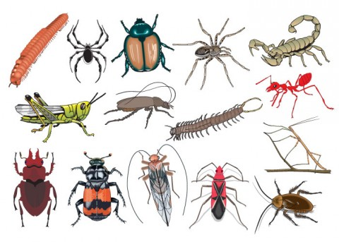  God has plans for bugs.  Bugs help flowers to grow fruits and seeds.  Without them, many plants would not be able to make fruits and seeds.  .  God has a special plan for you. God also plans that you will live with Him forever. What would you do for God?  So whether you eat or drink  or whatever you do,  do it all for the glory of God.  (1 Corinthians 10:31).  You are here on earth for a great purpose, created in Christ to do good works,  which God has prepared for you to do.  You are called by His name, and you are His! AWESOME!  Dear God,  thank you that I can be part  of your great purpose.  Thank you that I am called by Your name, and I am Yours.  *Verse of the week*  For we are God’s workmanship,  created in Christ Jesus to do good works,  which God prepared in advance  for us to do.  Ephesians 2:10

