



Week 3
April 29 –May 05, 2012

Fellowship
You were formed
for
God’s family

*Verse of the week*

So in Christ
we form one body

Romans 12:5a

Name:___________________________

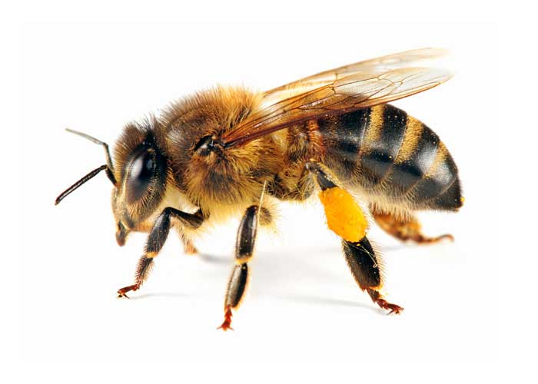

Bees work hard together to help everyone in the family.

God wants you to be
part of His family forever.

You have an important part to do in God’s family. God wants you to show love to those around you.

"Love your neighbor as you love yourself.” (Galatians 5:14)

God wants you to come to church.

God wants you to be a peace maker.
God will help you to be brave when it’s time for you to say sorry.

Dear Jesus, help me to love my church. Please bless my church teachers.

*Verse of the week*

So in Christ
we form one body

Romans 12:5a

