



Week 4
May 06 – 12, 2012

Discipleship

“You were created
to become like Christ”

*Verse of the week*

Your attitude should be the same
Like Christ Jesus.

Philippians 2:5

Name:_______________________

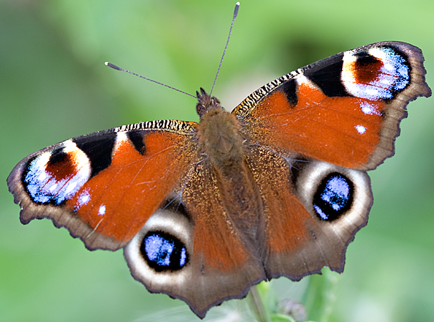

From a caterpillar
to a beautiful butterfly!

We are being changed
to become more like Jesus
2 Corinthians 3:18

You were created to become like Jesus
in everything you do, say, and think.

We will grow up into Christ in every way. Ephesians 4:15b

Dear God, please help me to read
the Bible every day.
I want to know more about you

God has a great purpose for you.
He begins a good work in you,
and will complete it in you
at the right time.
Just keep your focus on Him
and be patient!

Dear God,
I want others to know that I love you!

