Sunday, April 29, 2012

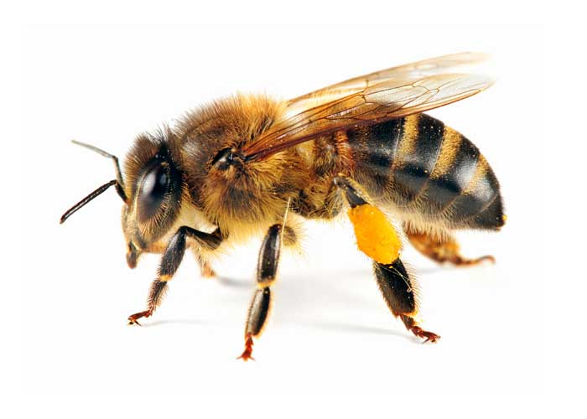
- Bug Byte: An Apis mellifera Linnaeus or…
a Honey Bee to you ☺

- Bible Byte: So He decided long ago to adopt us as His children. He did it because of what Jesus Christ has done. It pleased God to do it. (Ephesians 1:5)
- God decided to adopt you as part of His family. This is called spiritual family, and it will last forever. That’s the highest honor you could ever received!

- Dear Jesus, thank you that You have planned to adopt me and I can be part of Your family forever.

- Copy verse of the week
____________________________________________________________________________________________________________________________________________________

- Ask your parents what things that they do in God’s family.

Friday, May 04, 2012

- Bug Byte: Honey bee is the only insect that produces food eaten by man.
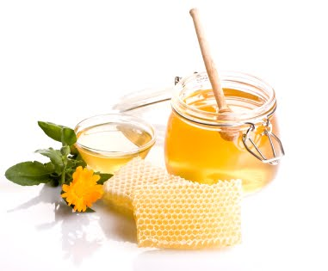
- Bible Byte: If possible, live in peace with every-one. Do that as much as you can. (Romans 12:18)

- God wants you to be a peace maker, and God expects you to make the first move. Saying sorry to others is part of living in peace.
- Dear Jesus, I want to live in peace. Help me to be brave when it’s time for me to say sorry.

- Copy verse of the week
____________________________________________________________________________________________________________________________________________________

- Ask your parents to share for times that they have to say sorry to someone.

Tuesday, May 01, 2012

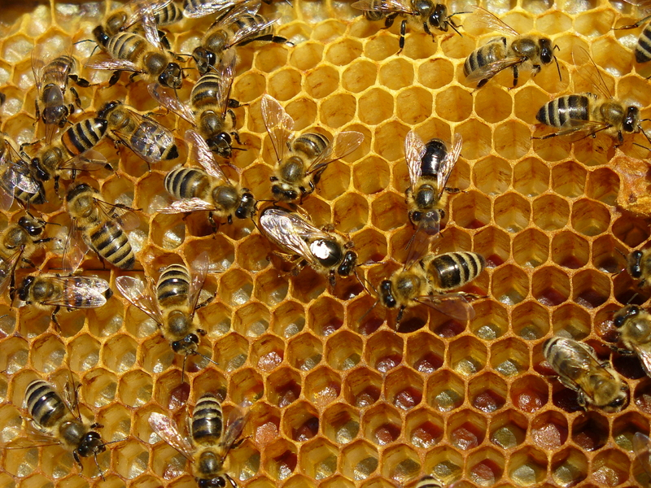
- Bug Byte: Honeybees work together for their colony; clean the hive, feed the baby bees, produce wax for the building of honeycomb cells, stand guard, collect food, and receive nectar from other bees.

- Bible Byte: In Christ we form one body, and each part of the body belongs to all the other parts. (Romans 12:5)

- You are a member of our church, and you have an important part to do. Do you know what your part is? Have you been doing your part?

- Dear Jesus, please help me to understand what my part is at church, and please help me to do it well.

- Copy verse of the week
____________________________________________________________________________________________________________________________________________________

- Ask your parents what their responsibilities are as part of God’s family at church.
Wednesday, May 02, 2012

- Bug Byte: Bees see all colors except the color red. Their sense of smell helps them find the flowers they need to collect pollen.

- Bible Byte: How good and pleasant it is when God’s people live together in peace! (Psalm 133:1)

- Life is meant to be shared with each other; the Bible calls it Fellowship. In fellowship we can share our joy and problems, and pray for each other. We need each other in our lives.

- Dear Jesus, please help me and my brothers and sisters at church to grow together in our fellowship.

- Copy verse of the week
____________________________________________________________________________________________________________________________________________________

- Ask your parents how they experience help from the people in their fellowship.

Thursday, May 03, 2012

- Bug Byte: Honey is the only food that contains antioxidant called pinocembrin. Antioxidant helps guard our body from getting sick.

- Bible Byte: We know what love is because Jesus Christ gave his life for us. So we should give our lives for our brothers and sisters. (1 John 3:16)

- Our brothers and sisters are the people in our fellowship. To give our lives for our brothers and sisters mean to think less of ourselves and think more of them.

- Dear Jesus, help me to think more about friends at church, because they are my brothers and sisters in You.

- Copy verse of the week:
____________________________________________________________________________________________________________________________________________________

- Ask your parents if they ever make a sacrifice for people from their fellowship.

Monday, April 30, 2012

Bug Byte: Honey bees live in a colony that consists of 20,000-60,000 honeybees and one queen. We can learn from them how to live peacefully with each other!

- Bible Byte: "Love your neighbor as you love yourself.” (Galatians 5:14)

- Do you know that “Love your neighbor as yourself” appeared in the Bible eight times? It must be really important to God. Those around you are your neighbors; Not just those that live next door to you.

- Dear Jesus, sometimes it’s not easy to love others. Please show me ways to love those around me, and help me to make the effort to love them.

- Copy verse of the week:
_______________________________________________________________________________________________________________

- Being a good listener, an encourager, a helper, and a gentle person is part of loving others. Ask your parents what they do to show love to others around them.
Saturday, May 05, 2012

- Bug Byte: Honey is the only food that includes all the stuff needed to sustain life. No wonder John the Baptist survived in the wilderness with only honey, locust, AND lots and lots of God’s Word ☺

- Bible Byte: So let us do all we can to live in peace. And let us work hard to build each other up. (Romans 14:19)

- It is your job to protect the peace and togetherness in our church. You can do the job by honoring those who serve you.

- Dear Jesus, help me to love my church. Help me be a peace maker at my church by honoring and supporting my leaders at church.

- Copy verse of the week:
_______________________________________________________________________________________________________________

- Pray with your parents for: our church leaders and pastors, your parents’ fellowship leaders and all your teachers at church.



What on Earth Am I Here For ?

Week 3
April 29 –May 05, 2012

Fellowship
“You were formed for God’s family”

*Verse of the week*

So in Christ we who are many form one body, and each member belongs to all others
Romans 12:5

Name:_________________________________

