Sunday, May 06, 2012
- Bug Byte: Did you scream “Eew!” when you see the picture below? Wait till you see what God did to it! Can you guess what this creature is called? *

- Bible Byte: We are being changed to become more like Christ Jesus so that we have more and more glory. And the glory comes from the Lord, who is the Holy Spirit. (2 Corinthians 3:18b)

- You were created to become like Jesus in everything you do, say, and think. God is very interested in what you are more than what you do.

- Dear Jesus, please help me watch what I say, do, and think. I want to be more and more like You.

- Copy verse of the week
________________________________________________________________________________________________________________________________________________________________________

- Ask your parents what they do to become more like Christ.

*It’s a Peacock Butterfly caterpillar ☺
Friday, May 11, 2012
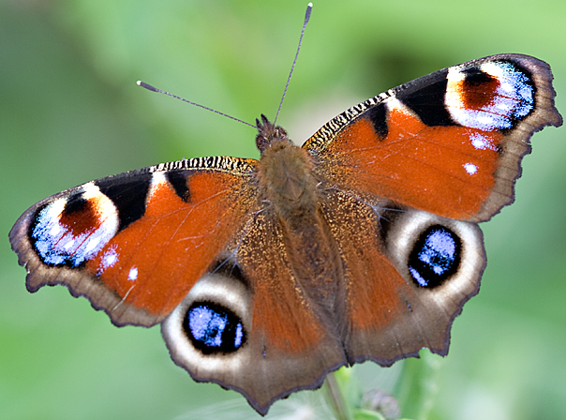

- Bug Byte: Here it is! Peacock Butterfly!
Drum roll, please ☺
Peacock Butterflies are native to England, Scotland, and Ireland.

- Bible Bytes: Run away from the evil things... Try hard to do what is right. (2 Timothy 2:22). God will not let you be tempted any more than you can take. God will give you a way out so that you can stand up under it. (1 Corinthians 10:13b)

- What’s tempting you? Could it be saying bad words? Or doing things that don’t please God? With God you can resist temptation! He will help you.

- Dear Jesus, please help me to focus on things that please You so I can resist temptation. Remind me that in everything I say and everything I do, I want to do it for Your glory.

- Copy verse of the week ________________________________________________________________________________________________________________________________________________________________________

- How did your parents resist temptation? Ask them to share with you their experience.

Tuesday, May 08, 2012

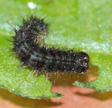
- Bug Byte: A caterpillar’s job is to eat, and eat, and eat for two to three weeks! Its body can grow more than a hundred times the size when it hatched!

- Bible Byte: Man shall not live
on bread alone, but on every word that comes from the mouth of God. (Matthew 4:4)

- If you want to become more like Christ, you need to pray and pray to God, and read and read God’s Word every day and obey it. A lot of people said that they believe the Bible, but they never really read it and obey it. Sad, right?

- Dear God, please help me to start reading the Bible, every day. I want to know you more. I want my faith in You to grow. Please help me to start ready my Bible everyday today.

- Copy verse of the week
________________________________________________________________________________________________________________________________________________________________________

- Ask your parents if they read their Bible every day. Ask them to remind you to read the Bible every day.

Wednesday, May 09, 2012
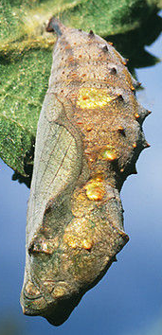
- Bug Byte: Then comes the time for the caterpillar to change to a chrysalis. Look at the picture! Doesn’t it look like the caterpillar is trapped in there? But don’t be fooled, a great change is happening in there! And, something good is about to come out of it!

- Bible Byte: We know that in all things God works for the good of those who love him. (Romans 8:28a)

- Have you ever had some troubles that actually brought something good in the end? The verse above said that our troubles are considered short in time compares to the glory in Jesus that will last forever.

- Dear God, help me to think and act in Your way. So I will see that all things will work together for good, even through my troubles.

- Copy verse of the week
________________________________________________________________________________________________________________________________________________________________________

- Ask your parents if they have had some troubles that actually make their faith in God stronger.

Thursday, May 10, 2012

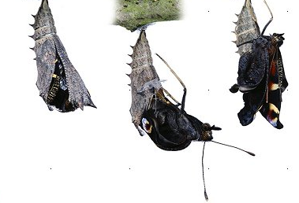
- Bug Byte: What comes out of the chrysalis? A butterfly! The butterfly has to push hard to make its way out from the chrysalis. However, the hard work helps it to gain strength to fly.

- Bible Byte: Bible Bytes: Blessed is the man who keeps on going when times are hard. After he has come through them, he will receive a crown. The crown is life itself. God has promised it to those who love him. (James 1:12)

- To fight temptation is hard; however it’s like an exercise that strengthens your faith in God. Moreover, God himself will give you the help to do it. Every temptation is an opportunity to do good deed and to grow. And one day your faith will come out beautiful like a Peacock Butterfly!

- Dear God, thank you that you are helping me to fight temptation so my faith in You will be stronger and stronger.

- Copy verse of the week
________________________________________________________________________________________________________________________________________________________________________

- Ask your parents about the time they fought temptation, and how their faith became stronger after that.
Monday, May 06, 2012

- Bug Byte: Caterpillar goes through a process called metamorphosis to become a butterfly. Metamorphosis means change in shape. There are 4 stages in the process.

- Bible Byte: We will no longer be babies in the faith. We will grow up into Christ in every way. (Ephesians 4:14a, 15b)

- God wants you to grow. The way you think will affect the way you feel and act. Do you think in ways that God wants you to think? Do you act in ways that God wants you to act?

- Dear God, please help me to think in God’s way, and not in my way. I also want to act in the way You wants me to. I want to grow up into Christ in every way.

- Copy verse of the week
________________________________________________________________________________________________________________________________________________________________________

- Tell your parents that you want to start thinking in God’s way. Ask them to pray for you, and to remind you when you’re thinking in your way again.

Saturday, May 12, 2012

- Bug Byte: Butterflies don’t have nose! They smell with their antennae, feet, (yes, feet!), and other parts of the body. Guess what? They also taste with their feet! Now, don’t try that at home; your mom is not going to be happy!

- Bible Byte: God, who began a good work in you, will carry it on until it is completed.
(Philippians 1:6a)

- God has a great purpose for you. He begins a good work in you, and will complete it in you at the right time. Just keep your focus on Him and be patient!

- Dear God, help me to grow good characters. I want to bring honor and glory for You, and when others see me, they will know that I have You in my heart.

- Copy verse of the week
________________________________________________________________________________________________________________________________________________________________________

- Can you list some good characters that God wants to grow in you? Ask your parents to pray for those characters for you.




What on Earth Am I Here For ?
Week 4
May 06 – 12, 2012

Discipleship
“You were created to become like Christ”

*Verse of the week*

Your attitude should be the same
as that of Christ Jesus.
Philippians 2:5

Name:_____________________________

