Moffat SMF – 2007 Narok Maasai Mission; Focus: Maasai Outreach

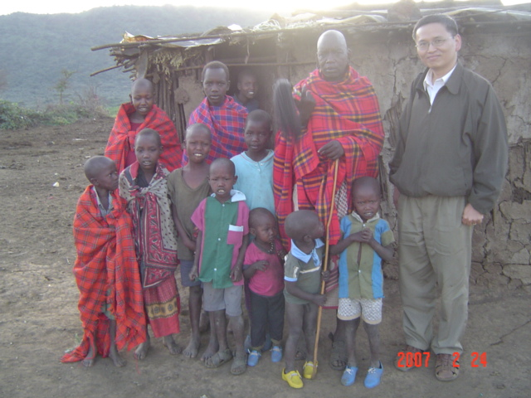  Our Host with Some of His Kids | 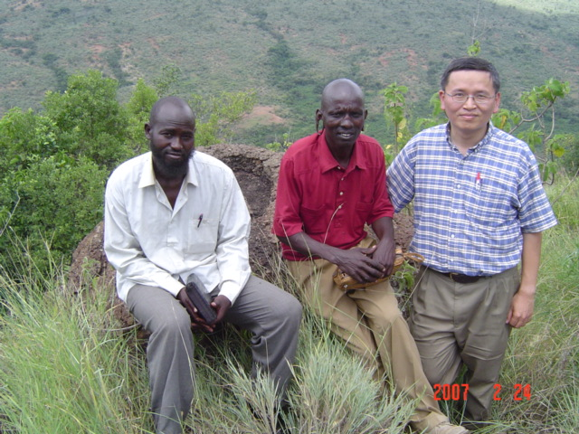  Proclaim God’s Authority in a Site of Witchcraft
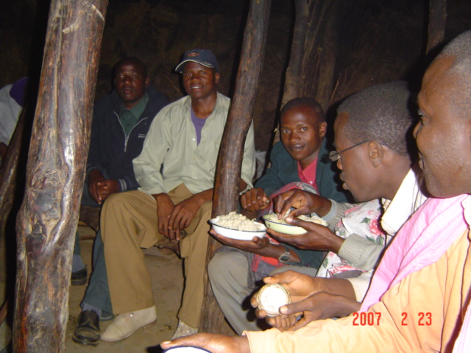  Huddling in a Manyatta & Eating with Hands | 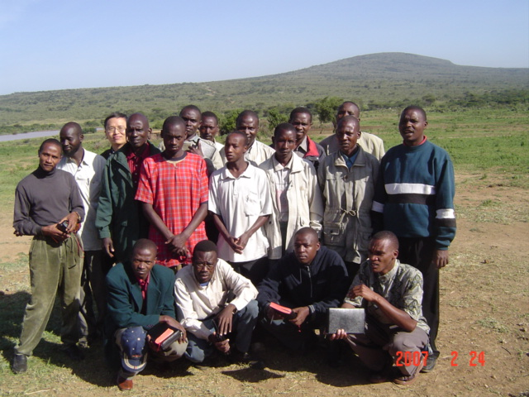  Departure for Door-to-Door Evangelism
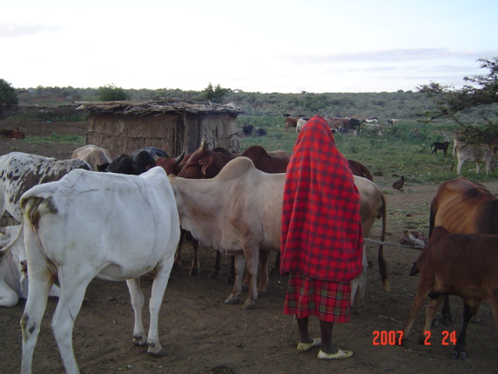  Cattle – Maasai’s Fortune | 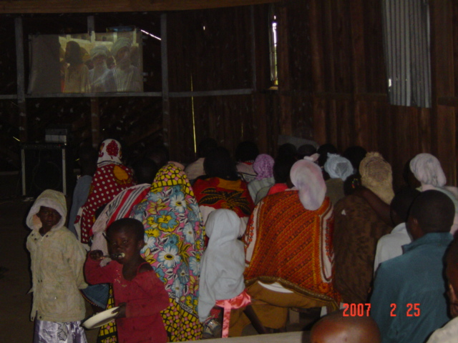  Showing Jesus Film in the Maa Language



